Grammatical Forms to Help ELLs
ED491D

Examples of Tenses and Aspects
- Simple Present: I ride the bus to school every day. Mario studies English.
- Simple Past: I rode the bus to school this morning. Mario studied English last year.
- Simple Future: I will ride the bus to school tomorrow. Mario will study English next semester.
- Tenses with Modals: I should (may, can, etc.) ride the bus to school tomorrow. Mario might study English next semester.
- Perfect Tenses: I have ridden the bus to school every day this year. Mario has studied English for three years. I had always ridden the bus until I got a car. Mario had studied English before he immigrated to the Unites States.
- Perfect Tenses with Modals: I should have ridden the bus to school this morning. At the end of this semester, Mario will have studied English for five years.
- Tenses with Progressive –ing: I’m riding the bus to school tomorrow (Present progressive functioning as future). Mario has been studying English for five years.
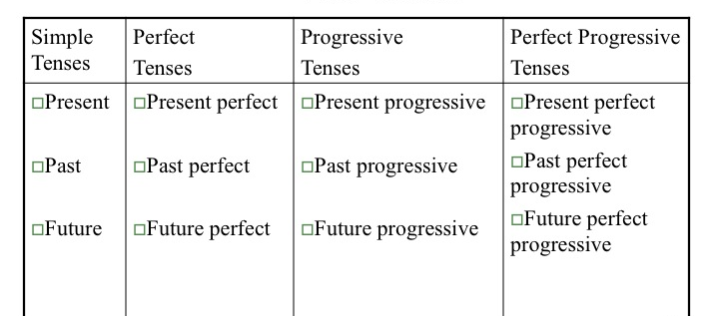
 | Simple Forms | Progressive Forms | Perfect Forms | Perfect Progressive Forms
Present | take | am/ is/ are taking | have/ has taken | have/ has been taking
Past | took | was/ were taking | had taken | had been taking
Future | will/ shall take | will be taking | will have taken | will have been taking
Sentence Structure
- Simple subject + verb (+NP)
- Simple subject + verb with compound subject or verb phrase
- Compound sentences: Two or more subject + verb (+NP)
- Complex sentences with subordinate clauses
- Complex sentences with relative clauses

Examples of Sentence Structures
- Simple subject + verb: Rebecca eats pizza.
- Simple subject + verb with compound subject or verb: Rebecca and Jessica eat pizza. Rebecca eats pizza and drinks soda.
- Compound sentences: Rebecca eats pizza and she drinks soda. Rebecca eats pizza, but she doesn’t drink soda. (Note the coordinate conjunctions, and a but, which signal a relationship between the two independent clauses)
- Complex sentences with subordinate clauses: Subordinate clauses are sentences within sentences. They can be introduced with a subordinate conjunction that expresses the relationship between the main clause and the subordinate clause. Rebecca eats pizza because she likes it. Rebecca drinks soda after she eats the pizza. Rebecca drinks soda when she eats pizza. Rebecca likes pizza better than Jessica does. (In these examples, note that “Jessica” is the subject of the subordinate clause, and “does” takes the place of “likes pizza.”) Other examples: Mary stayed home from school because she felt sick. After the students returned from gym class, the alarm sounded for a fire drill. Katie held the door open while the students filed out. (Note again that the subordinate conjunctions, when, better than, because, after, while, indicate a relationship between the main and subordinate clauses.)
- Complex sentences with relative clauses, including deleted relative pronouns, e.g., The man talking on his cell phone ran the stop sign. The man [who was] talking on his cell phone ran the stop sign. Mario read the instructions to Al, who carried out the experiment.

Negation
Negation can occur in independent and dependent clauses:
- Rebecca doesn’t like pizza, but she likes seafood.
- Rebecca likes pizza, but she doesn’t like seafood.
- Rebecca doesn’t like pizza, and she doesn’t like seafood either.
- Mary stayed home from school because she didn’t feel well.
- Mary didn’t stay home from school even though she didn’t feel well.

Indirect Speech
Indirect speech can be difficult for the English learner. Dependent clauses in indirect speech are introduced with “for” or “to.” John asked Sally to open the window. Robert asked for the waiter to bring the check. (In the latter case, he didn’t speak directly to the waiter.) John told us to go ahead. John said for us to go ahead. Using “for” or the “to” construction depends on the main verb, tell or say.

Prepositional Phrases
Prepositions can be difficult because they are subtle, and they may be used in ways different from their counterparts in other languages. There is a tendency to think of prepositions in terms of the obvious locational ones (under, near, etc.) and lose sight of the many ways prepositions affect meaning:
- The cat sleeps under the chair. (location)
- The man in the white hat is always the good guy. (prepositional phrase functions as adjective)
- The deer disappeared into the fog. (movement)
- The president talked around the topic. (manner, attitude)
- I dreamed about my homework assignment.
- Martin Luther King dreamed of a brighter future. (Note the difference in meaning between dream about and dream of)

Vocabulary Forms
Frequency Lists
Frequency lists of nouns, verbs, adjectives (frequency usually includes function words that perform syntactic roles such as prepositions and modals). For content words (nouns, verbs, and adjectives), it’s reasonable to think that more frequent words are more readily acquired and are therefore “easier.”

Subtle and Rich Synonyms
ELL students often use relatively general words, and often, teachers use simplified vocabulary to make meaning more comprehensible. However, ELL students need to learn the subtle distinctions of vocabulary, e.g., look, stare, glare, gaze, peer, watch, see.

Two-Word Verbs
Two-word verbs can resemble verb + preposition but mean different things: Look up a word v. Look up a chimney. Get on the bus v. Get on with your business.

Prefixes
Language arts classes cover such prefixes as un-, mis- and re-. However, some prepositions can serve as prefixes to create new words: outshine, outrun, overeat, overdo, overreact, underachieve, undercut.

